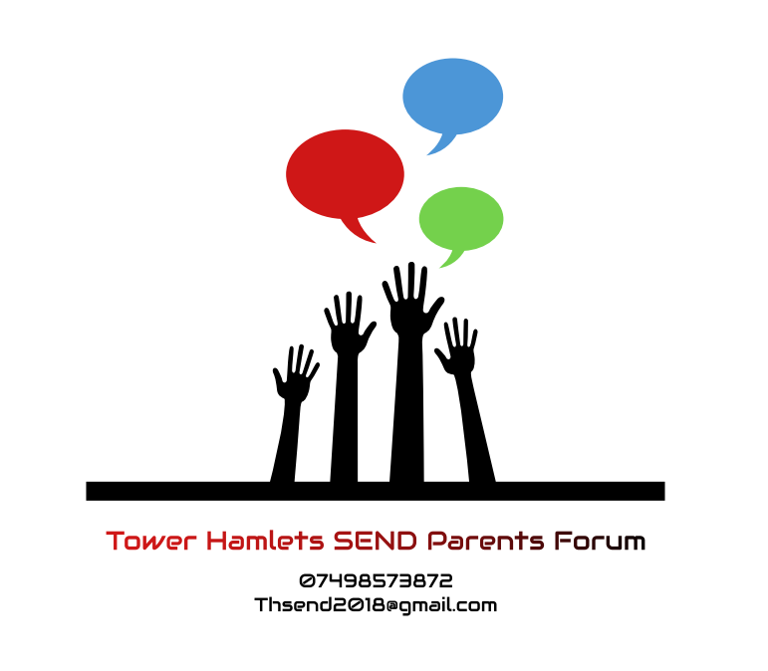

What are we working towards?

VISION
Tower Hamlets Independent SEND parents forum will be a well informed, connected and empowered community of families of children with Pan disabilities or additional needs, offering support to each other and working in partnership with service providers and Local Authority to create quality services that meet the needs of all parent carers and their children.

GOAL
Members of Tower Hamlets Independent SEND parents’ forum will work collectively for all families respect each other’s views & make best use of one another’s skills & resources.
We aim to provide opportunities for parent carers to influence the decisions that affect their families and to contribute to developing services that meet the needs of their families

