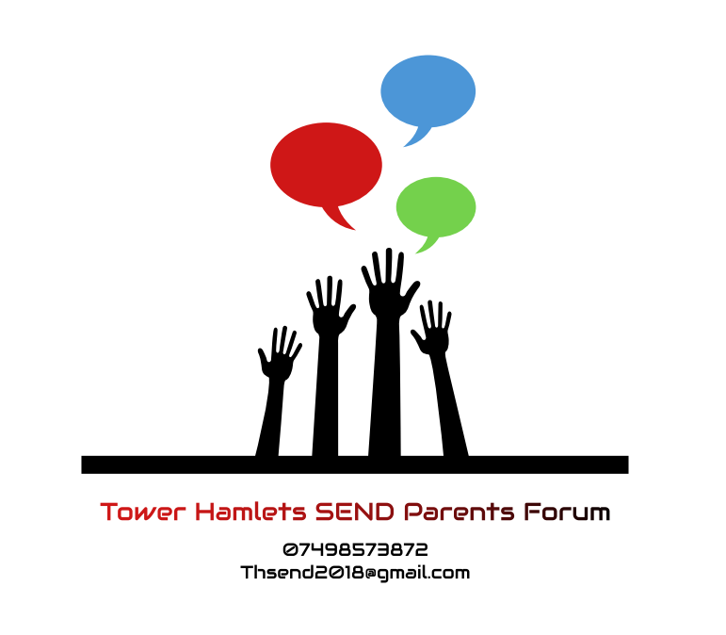

CODE OF CONDUCT

1. WHAT IS A CODE OF CONDUCT?
The Steering Group has responsibility for all actions carried out by staff and Steering Group Members. As a result the conduct of Steering Group Members and staff, and any other individual parent carers who are acting on behalf of Terms of reference for Tower Hamlets Independent SEND Parents’ Forum should give our Member Forums, partners and funders confidence. All individuals covered by the Code of Conduct need to show integrity; ensure actions are transparent and avoid any suggestion of improper influence. There must be no abuse of authority in our actions. All Steering Group Members and staff are required to uphold the spirit, as well as the wording, of this Code of Conduct.
This „Code of Conduct‟ includes the findings of the Nolan Committee on “Standards in Public Life”, and goes beyond these. The term „we‟ and „us‟ have been used throughout to show that the Code of Conduct applies to Steering Group Members and staff equally.

2. FINDINGS OF THE NOLAN COMMITTEE
The seven principles of public life identified by the Nolan Committee guide the content of our Code of Conduct.
• Selflessness: take decisions in terms of Terms of reference for Tower Hamlets Independent SEND Parents’ Forum values and mission and not to gain financial or material benefits for ourselves, our family and friends other than in the case of universal benefit.
• Integrity: not place ourselves under obligations to individuals or organisations that might influence us in the performance of our duties.

• Objectivity: to ensure that we represent, at all times, a range of disability, Special Educational Needs, cultures, social backgrounds and geographical areas.
• Accountability: accept accountability for our decisions and actions to Terms of reference for Tower Hamlets Independent SEND Parents’ Forum Members, the providers of public funds and other stakeholders, and submit us to appropriate scrutiny.
• Openness: be open about all decisions and actions that we take. When required to give reasons for our decisions.
• Honesty: declare private interests relating to our duties and take steps to resolve conflicts arising in a way that protects Terms of reference for Tower Hamlets Independent SEND Parents’ Forum reputation, values and mission.
• Leadership: promote and support these principles by leadership and example.
•

3. DISCLOSURE OF INTEREST
3.1 This covers circumstances where an individual (or their close relative) could in theory receive a personal or business benefit (other than Honorarium/Salary and expenses) as a consequence of Tower Hamlets Independent SEND Parents’ Forum reputation activity. There are two main examples where a benefit could occur:
3.1.1 A Duality of Interest. Where the circumstances could potentially bring about some personal or business gain;
3.1.2 A Conflict of Interest. Where a Tower Hamlets Independent SEND Parents’ Forum reputation interest and a personal/business/other Voluntary Sector interest occurs over the same matter.
3.2 Both types of interest must be disclosed. The Operations Manager is responsible to ensure that annually members complete a declaration form. These forms will be held in a register that is open to public scrutiny.
4. AIMS AND VALUES
4.1 Our work and reputation relies on us upholding and promoting Tower Hamlets Independent SEND Parents’ Forum’s aims and values.
4.2 We should all work to the same aims and uphold the same values. We are required to incorporate these in our conduct in relation to Tower Hamlets Independent SEND Parents’ Forum
5. POLITICAL ACTIVITIES
5.1 Tower Hamlets Independent SEND Parents’ Forum work may take it into the political arena but we must ensure that we demonstrate our non-political nature, and are impartial about party politics. When making any political representation, Tower Hamlets Independent SEND Parents’ Forum must clearly be seen as presenting a balanced case in support of Tower Hamlets Independent SEND Parents’ Forum’s key objectives
5.2 Members can engage in political activities, including standing for election to public office, as long as it is legal to do so. However participation will be entirely on their own behalf and their political opinions will not represent the Tower Hamlets Independent SEND Parents’ Forums position.
6. EQUALITY AND DIVERSITY
6.1 Tower Hamlets Independent SEND Parents’ Forum is committed to achieving equality of opportunity in every area. Our aim is that everyone should be treated fairly and be equally respected and represented. The aim is to ensure that Tower Hamlets Independent SEND Parents’ Forum reflects its Member Forums.
7. PERSONAL CONDUCT
7.1 As a representative of parent carers across Tower Hamlets the Steering Group Member Role has clear responsibilities and requirements in relation to personal conduct, and expects any member who represents the Tower Hamlets Independent SEND Parents’ Forum must strive to establish and maintain the trust and confidence of our wider membership, and partners whom we work with.
8.2 You must not bring the Tower Hamlets Independent SEND Parents’ Forum into disrepute while acting in your representative capacity. As a steering group member, your actions and behaviour are subject to greater scrutiny than that of ordinary members of the public. You should be aware that your actions in both your public and private life might have an adverse impact on your own role, and the Tower Hamlets Independent SEND Parents’ Forum
8.2 Those who represent the Tower Hamlets Independent SEND Parents’ Forum must ensure that in their conduct and activity they:
• Conduct ourselves appropriately for the duty or function that we are carrying out or attending, which includes treating all of those we come into contact with courteously and with dignity and respect.

• Respect diversity and different cultures and values.

• Are honest and trustworthy;

• Communicate in an appropriate, open, accurate and straightforward way;

• Respect confidential information and do not share any information that is confidential outside of the Steering Group

• Are reliable and dependable, or provide clear information to the chair if they are experiencing challenges that may prevent them from being so.

• Honour work commitments, agreements and arrangements and, when it is not possible to do so, explaining why to the chair and other steering group members as appropriate

• Ensure that the views of parent carers are fully and accurately represented. Whilst personal experience may inform this, we must not rely entirely on own experiences, views and judgements, but be fully representative of the wider membership.

• Declare issues that might create conflicts of interest and making sure that they do not influence your judgement or practice

• Behave in a way, in work or outside work, which would call into question your suitability to be a representative of other parent carers

8.3 Steering Group members must inform the chairs about any personal difficulties that might affect your ability to exercise your responsibilities appropriately. As members of the Steering Group are expected to work in partnership at the highest level with various Local Authority and health partner Departments, any personal circumstance which may pose a conflict for individuals, and therefore for the organisation must be declared to the chair immediately
The following are examples of types of circumstances
• Any allegation that an individual may have committed, or is being investigated in relation to having committed a crime
• Any child protection or safeguarding concern relating to children and / or vulnerable adults.
• Any significant challenge between individuals and Government agencies (e.g. where individuals may end up in a litigious relationship with a central or local Government Department)
• Other similar circumstances

8.4 In these situations, it will be standard practice to ask the Steering Group member to temporarily stand down until the issues are resolved. This is a neutral and non-judgemental position, designed to protect the organisation and the individual, and to ensure the individual involved is able to focus all of their attention on the issue at hand. It is felt necessary however to insist on this protocol to safeguard both the Tower Hamlets Independent SEND Parents’ Forum and the individual involved.
8.5 Consideration will be given as to how the roles and responsibilities of that individual will be covered in their absence, and whether a temporary replacement should be sought.
9. GENERAL
9.1 Where our personal conduct may be viewed as conflicting with the work of Tower Hamlets Independent SEND Parents’ Forum, we are required to disclose details to the chairs, and enter details in the „Disclosure of Interest Register‟. Advice on any matter in this Code of Conduct should be sought from the Operations Manager
9.2 In any case of uncertainty, we should always make an entry in the „Disclosure of Interest Register‟ and / or seek advice and make a record of this.
9.3 We should carry out our responsibilities in accordance with Tower Hamlets Independent SEND Parents’ Forum policies and procedures.
9.4 All of us represent Tower Hamlets Independent SEND Parents’ Forum
10. FAILURE TO FOLLOW CODE OF CONDUCT
10.1 We should recognise that failure to follow this Code of Conduct may damage Tower Hamlets Independent SEND Parents’ Forum and will be viewed as a disciplinary matter
10.2 In the event of an alleged breach of the Code, any investigation or action will be initiated by the Chairs. Based on the outcome of the investigation, a range of actions may be taken ranging from seeking appropriate training and support for the individual member, to asking them to permanently step down, depending on the severity and impact of any alleged breach.
Reviewed October 2019

